**Lesson 4 Demo 6**

**Switching Branches in Git**



Steps to be followed:

1. Create a new branch
2. Switch to the new branch
3. Create a file and commit the changes
4. Check the status of the new branch
5. Switch back to the main branch

**Note**: A **projectfile** is already created in Demo 5. If you do not have a repository, first perform that demo and then execute the steps from this demo.

**Step 1: Create a new branch**

1.1 Open the Terminal in your lab, and navigate to the **projectfile** folder

**cd projectfile**

1.2 Execute the following command to create a new branch:

***git branch text_branch***



**Step 2: Switch to the new branch**

2.1 Use the following command to switch to the newly created **text_branch**:

***git checkout text_branch***

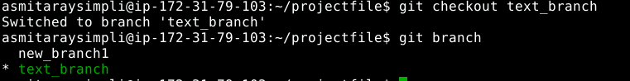

**Step 3: Create a file and commit the changes**

3.1 Use the following command to create a file:

***vi index.html***



3.2 Add the following code snippet in the **index.html** file  
  
 **<html>**

**<body>**

**<p> This is a Test HTML file. </p>**

**</body>**

**</html>**

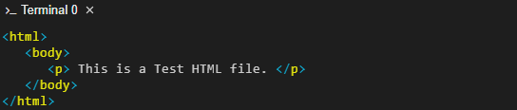

**Note:** Press **Esc** button and enter **:wq** to save the file.

3.3 Use the following commands to add the file to the **text_branch,** and commit the changes:

***git add index.html***

***git commit -a -m "file modified"***

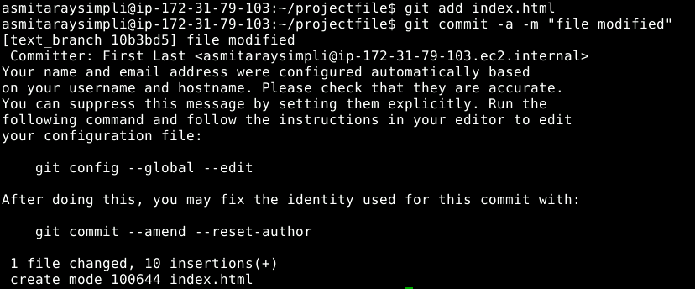

**Step 4: Check the status of the new branch**

4.1 Check the status of the new branch using the following command:

***git status***



**Step 5: Switch back to the main branch**

5.1 Check the current branch using the following command:

***git branch***

5.2 Use the following command to switch back to the main branch:

***git checkout new_branch1***

